Project Report Temple

Implementing CRM for Result tracking of a candidate with internal marks

1 INTRODUCTION

1.1 Overview

Administrator should be able to create all base data including Semester, Candidate, Course and Lecturer. Lecturer should have the ability to create Internal Result, Dean who is one of the Leturer should be the only one with ability to update Internal Result, Re-evaluation Can be initialized by Candidate for all Internal Results. Now only only dean update the marks after re-evaluation.

1.2 Purpose

It aimsto produce areal time knowledge of the salesforce and how can we build a app using salesforece in this project we build a Candidate results card application for educational institution,which would be usseful for he staffs to reduce time and track the performance of the students with ease it is helpful to have large number of data maintained under one platform.

2 PROBLEM DEFINITION & DESIGN THINKING

2.1 Empathy Map

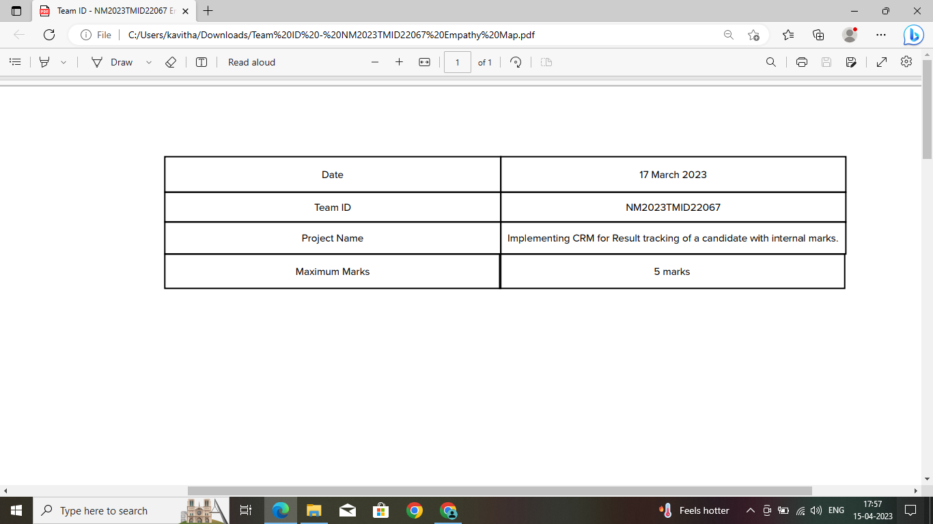 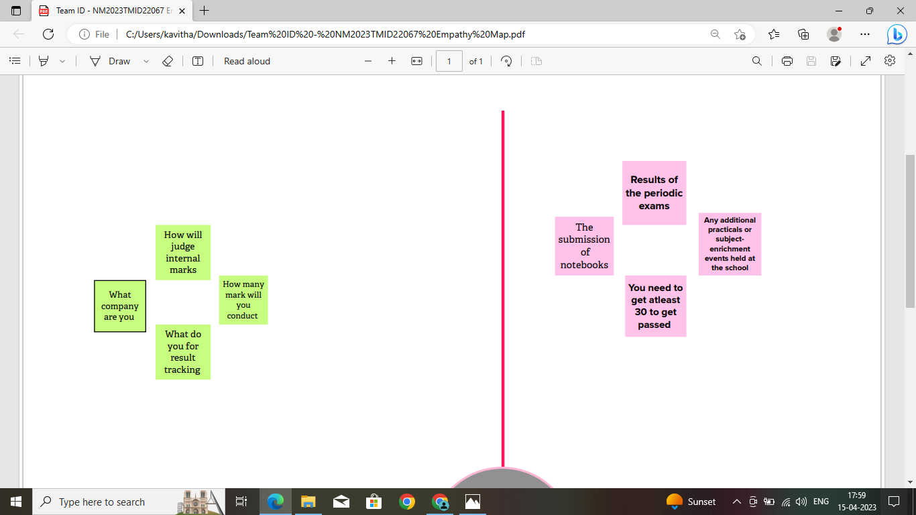

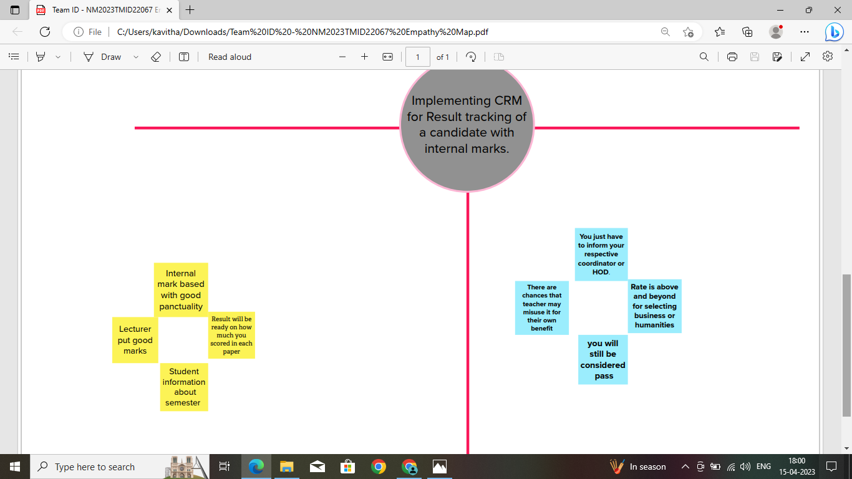

2.2 Ideation & Brainstroming

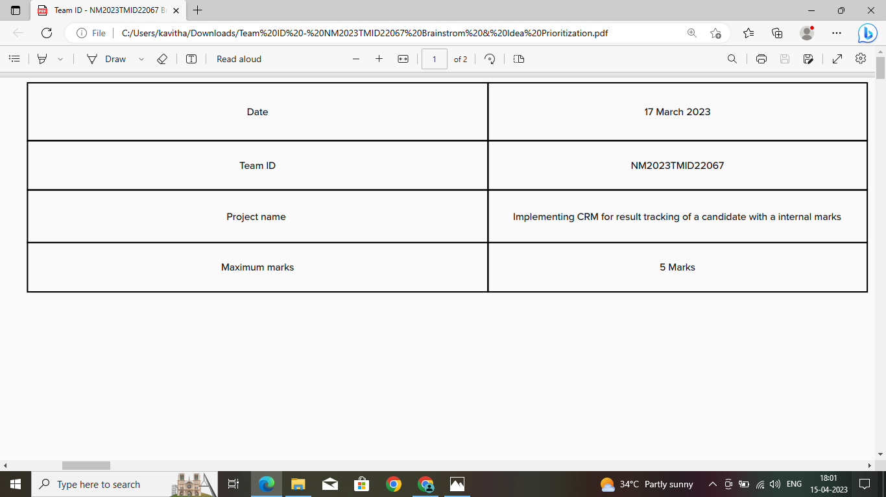

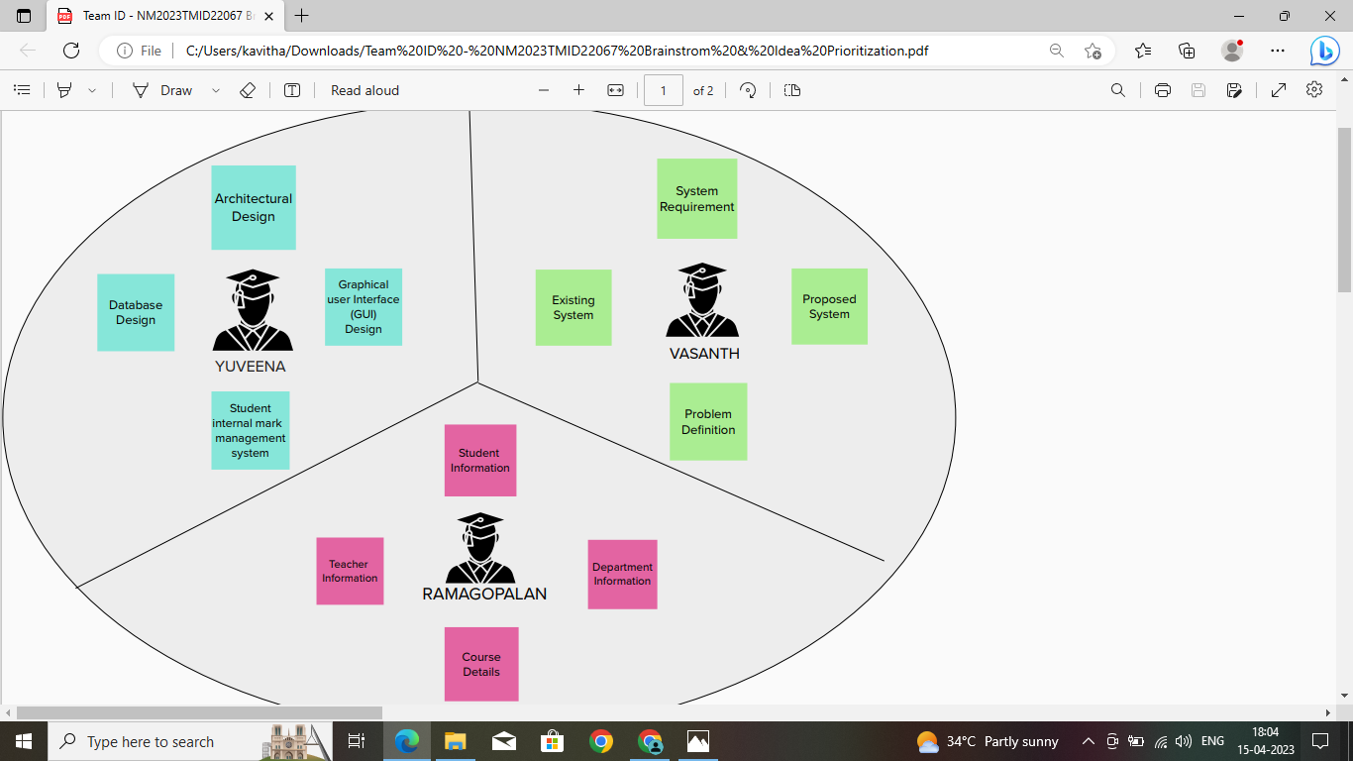

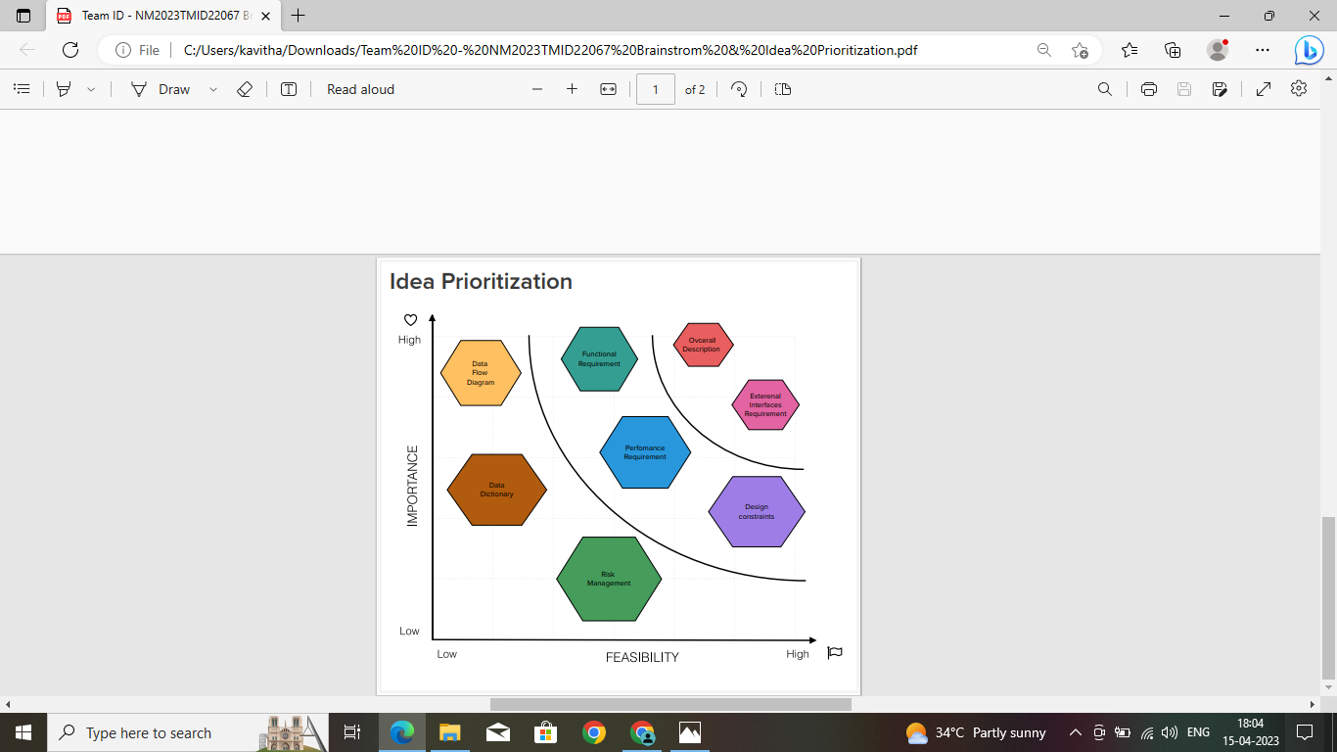

3 RESULT

3.1 Data model

|  |  |
| --- | --- |
| OBJECT NAME | FIELDS IN THE OBJECT |
| SEMESTER | FIELD LABEL:  SEMESTER NAME  COUSE( LOOKUP)  DATA TYPE:  TEXT |
| CANDIDATE | FIELD LABEL:  CANDIDATE NAME  CANDIDATE ID  SEMESTER NAME  INTERNAL RESULTS(LOOKUP)  DATA TYPE:  TYPE |
| COURSE DETAILS  LECTURER DETAILS | FIELD LABEL:  COURSE NAME  COURSE ID  DATA TYPE:  TEXT  FIELD LABEL:  LECTURER ROLE  LECTURER NAME  COURSE ID  COURSE(LOOKUP)  DATA TYPE:  TYPE |
| INTERNAL RESULTS | FIELD LABEL:  CANDIDAT ID  COURSE ID  MARKS  DATA TYPE:  TEXT |

3.2 ACTIVITY AND SCREENSHOT

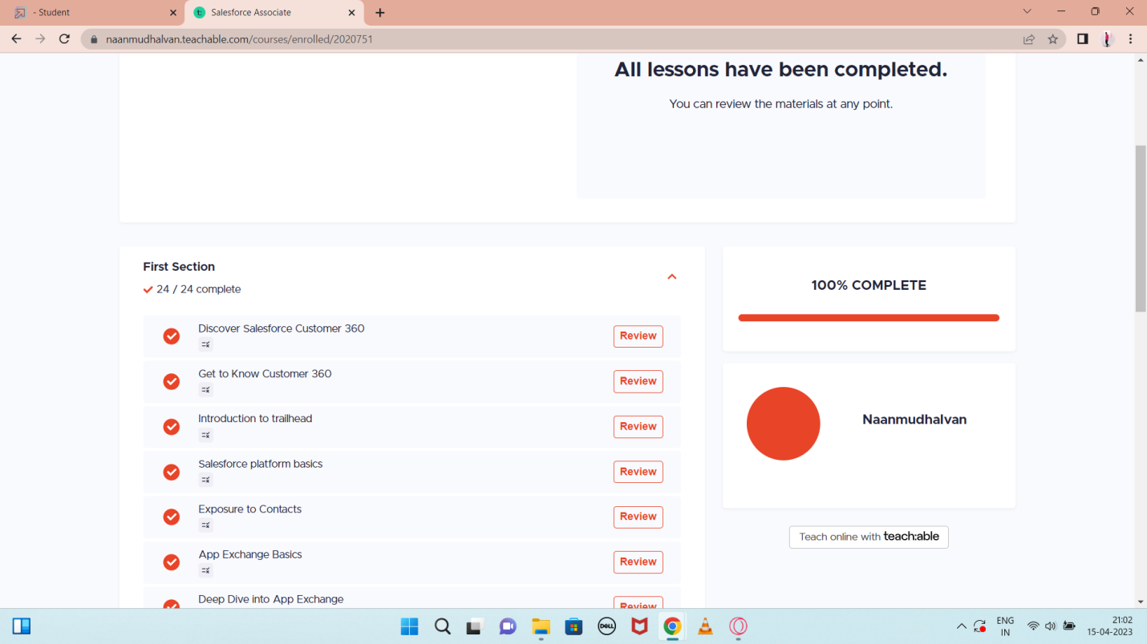

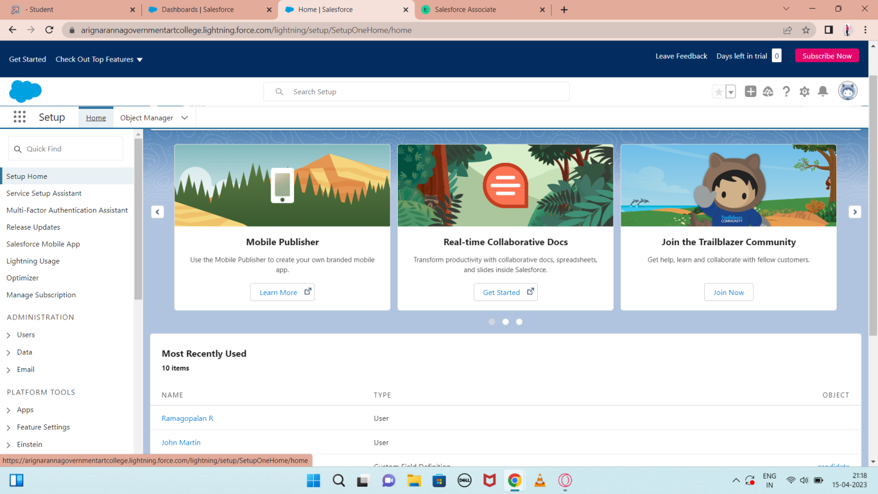

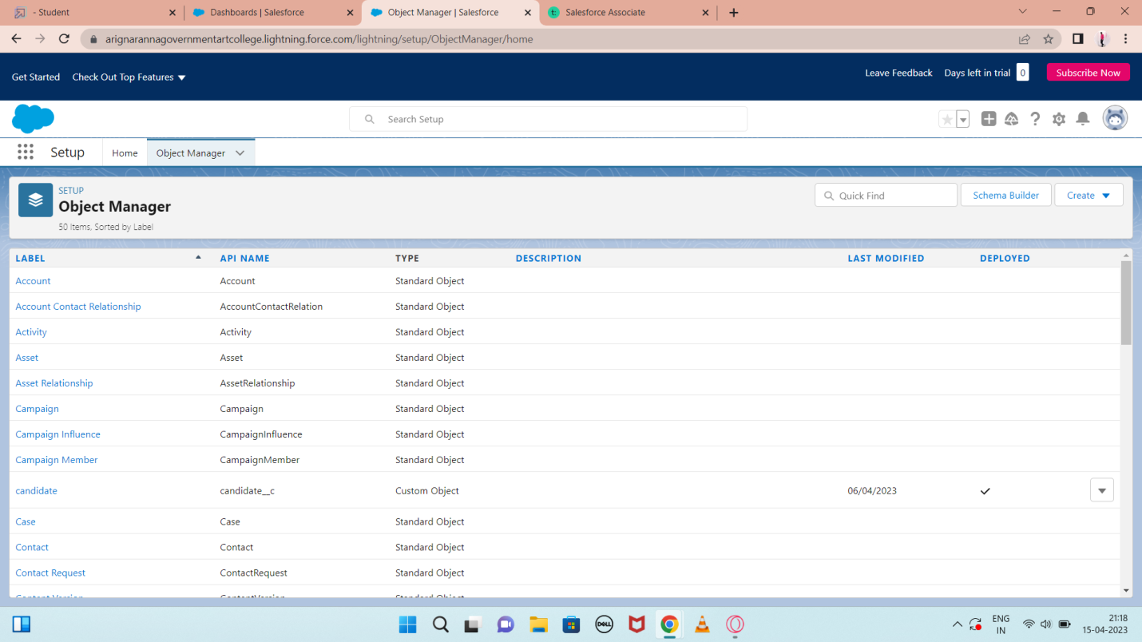

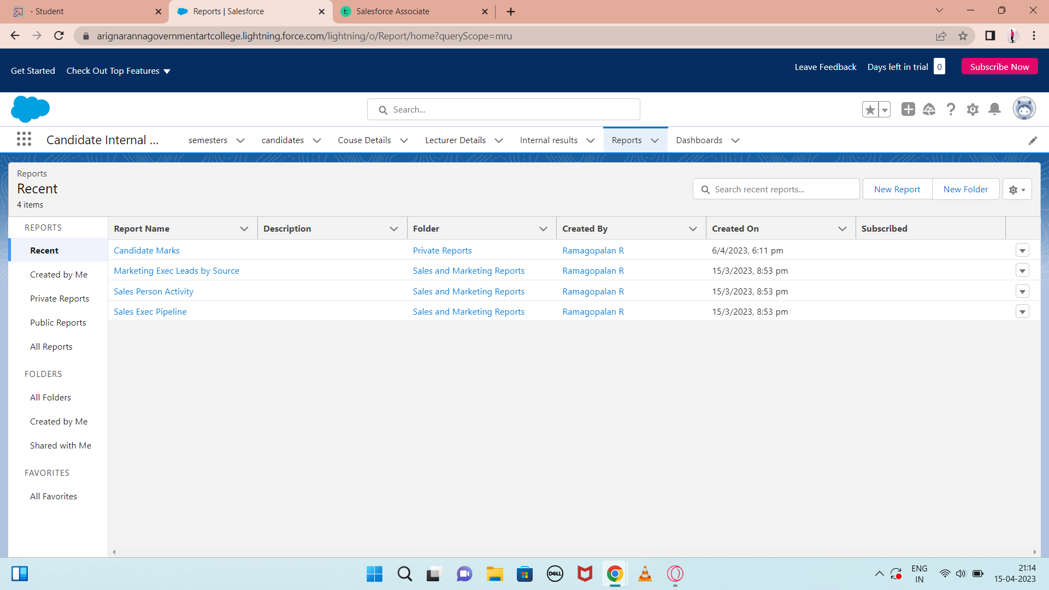

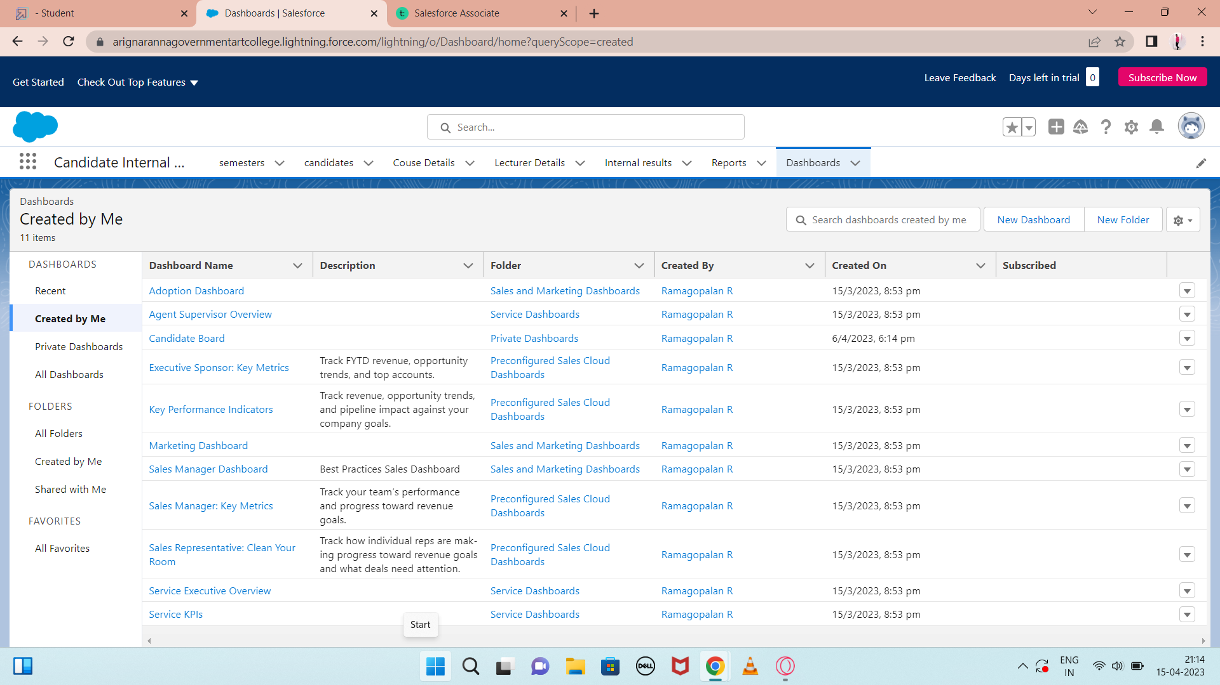

4 Trailhead Profile Public URL

Team Lead -

Team Member 1 *-* trailblazer.me/id/ramar134

Team Member 2 –

5 ADVANTAGS & DISADVANTAGES

* Advantages
* It allows for theconsolidtion data and the basis for deep.
* It speeds up the sales conversion process.
* It increases staff productivitylowering time-cost.
* It allows geographically dispersed teams to collabrate effectively.
* Improves cstmer experience by allowing personalization and improvd query resolution.
* Disadvantages
* Customer experience may worsen due to staff over-reliance on the system.
* Security and data protection issues with centralized data.
* The excess iitial time and productivity cost at the implementation.
* Requires a process-driven also organisation.
* CRM may not suit all businesses.

6 APPLICATIONS

* I want something reliable
* Target marketing
* Increases candidate quality
* Can work easily
* Streamlining internal sales processes

7 CONCLUTION

Students Internal Mark Management System desls with details, academic related reports, college detail and course details. Ittracks all the details of a student from the day on to theend of his course which can be used for all reporting purpose, tracking of progress in the course, completed semeter, upcoming semester details, exam details project or any other asignment details, and final exam result.

8 FUTURE SCOPE

Scope of educations means range of view, outlook, field or opportunity of activity, operation and application of education. Education has a wider meaning ad application.